MAP1_14 quick reference
Ray Meddis, University of Essex, Colchester, UK CO7 9SW.
Email: rmeddis@essex.ac.uk.
Update 26 September 2011
1 What is MAP 1_14? 1
2 Installation 2
3 Demonstration programs 3
4 MAP 1.14 8
5 Displaying the output using UTIL_showMAP.m 13
6 Physiology check-up 15
7 Auditory profiles using multiThreshold 17

What is MAP 1_14?
MAP1_14.m is the latest version of the Matlab Auditory Periphery (MAP) model from Essex University, UK. It is a computer program that simulates all stages of the auditory periphery up to the auditory nerve (AN) and into the brainstem.
MAP1_14 also has efferent functionality including both acoustic reflex and MOC efferent function,.
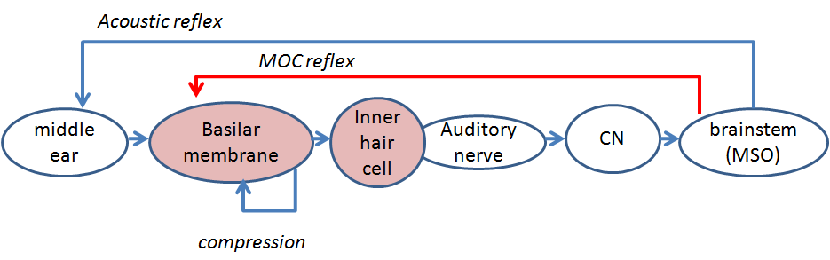
Figure 1. Schematic of the auditory pathway modelled by MAP1_14. Each circle represents a separate stage of signal processing in the auditory periphery.
The model is realised by systems of equations that are given in detail in the accompanying document MAP 1_14 Model description.doc.

Installation
The software comes in a zipped folder called MAP1_14.
Unzip the folder and locate it anywhere on the hard disk.

Folder structure
The folder structure has been designed to minimize MATLAB path problems and enhance protability.
The beating heart of the system is a program containing the model equations. It is called ‘MAP1_14.m’ and can be found in the folder MAP1_14\MAP.
The parameters to be used with the MAP model equations are combined in a single parameter file. Different parameter files exist to model both normal and impaired hearing. These files are located in the folder MAP1_14\ parameterStore
Demonstration and test programs to run the model and allow the new user to explore its potential can be found in the folder MAP1_14\testPrograms. Some examples are given immediately below.
Another folder, MAP1_14\multithreshold 1.46 contains psychometric testing software which can be harnessed to the MAP model so that the model can be tested in the same way as laboratory subjects or clinical patients.
Acoustic stimuli are stored as .wav files in the folder MAP1_14\wavFileStore.
Users can write their own programs to control the model. These programs should be stored in the folder MAP1_14\userPrograms. The user is strongly encouraged to put his programs here to avoid problems with MATLAB paths.
The folder MAP1_14\utilities contains some utility functions that are shared across programs and can be accessed by the user.

Demonstration programs
To get started quickly, you can use the demonstration programs in the testPrograms folder.
Two programs ‘demoTwisterProbability’ and ‘demoTwisterSpikes’ both take the acoustic input from a .wav file, twister_44kHz.wav, and process it through the model. This .wav file contains the word ‘twister’ spoken by the author.

demoTwisterProbability
The first program, demoTwisterProbability, plots the simulated auditory nerve response to this acoustic stimulus. In the command window type
run demoTwisterProbability
The model processes 21 channels with best frequencies (BFs) between 250 Hz and 8 kHz.
The program plots the model response at four stages (stimulus, stapes, basilar membrane (BM) and auditory nerve (AN). This is shown Fig. #A (left panel).
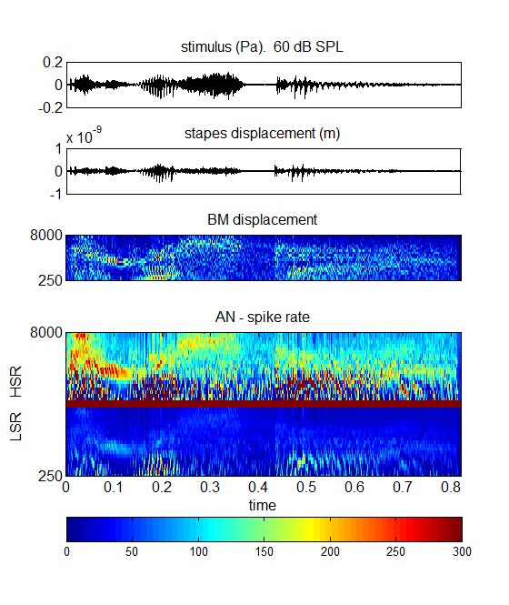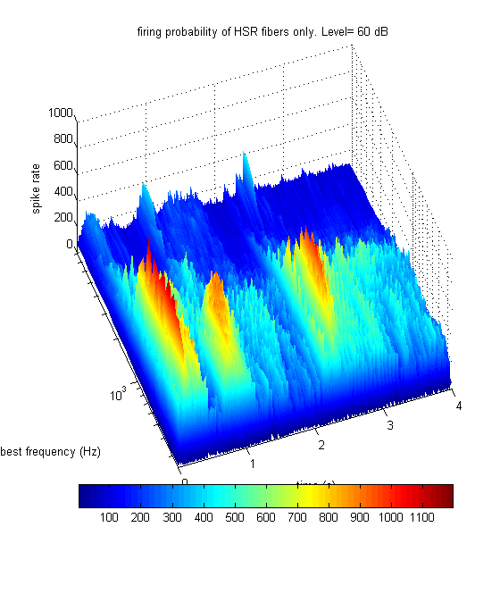
Figure 2
Left panel: Model output for the demonstration file demoTwisterProbability. The input utterance is the word ‘twister’ spoken at an rms level of 60 dB SPL by a male speaker. The model has 21 channels with BFs between 250 and 8000 Hz (evenly spaced on a logarithmic scale). The top three panels represent the signal, stapes displacement and basilar membrane displacements respectively. The bottom panel shows the AN response firing probability computed for both high and low spontaneous rate fibers in the upper and lower part of the panel respectively.
Right panel: Surface plot of the high-spontaneous rate fiber response only. This is based on the same data as the upper half of the bottom pane to the left.
Two types of auditory nerve fiber are illustrated; high-spontaneous rate (HSR) and low-spontaneous rate (LSR) response. A second image (Fig. #, right panel) is generated showing only the HSR fiber response as a surface plot. The plot represents the probability of action potentials scaled up to represent firing rates in each BF channel
Warning: When you run the program, the figure you obtain may differ in detail from the pictures shown here. Changes to the parameter files will have this effect and these pictures do not always get updated when the standard parameter file is changed.

Hands on.
Save the program with a new name into the userPrograms folder and then read through the code. It is written so that you can start experimenting immediately with changes (e.g. no of channels, signal level, etc).
The code prepares the signal for processing, selects important options and then calls the MAP1_14 software which runs the model. When the computations are complete, the code calls the UTIL_showMAP function to display the results.

demoTwisterSpikes
The second program, demoTwisterSpikes, illustrates a full spiking model. In the command window type
run demoTwisterSpikes
It computes the AN response as spikes and then uses these spikes as the input to arrays of neurons in the cochlear nucleus and higher in the brainstem. In both cases the neurons are configured as simple chopper cells with regular firing patterns.
This model simulates the response of both HSR and LSR AN fibers and two streams of brainstem units that derive their input from these two groups of fibers.
Only 11 BF channels are used in this example so that the spiking patterns are easier to see. The spike plots are horizontal rows (rasters) of spikes. Each row is the simulated spiking pattern of a single AN fiber. There are 100 AN fibers of each fiber type in each channel (total 2 x 11 x 100 fibers) and 10 CN neurons in each channel in each fiber-type stream (2 x 11 x 10). At the second level, there is one neuron in each BF channel in each fiber-type stream (2 x 11 x 1).
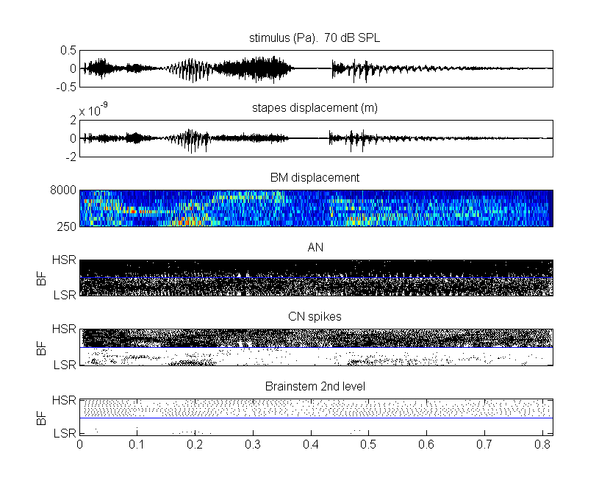
Figure 3. Model response to the utterance ‘twister’. The first three panels are the same as the previous figure (signal, stapes response, BM response). The auditory nerve response (panel 4) is given as a raster plot of actual spike activity in 11 channels for two types of fiber (2200 fibers altogether); HSR (top of the matrix) and LSR (bottom of the matrix). The bottom two panels show the spiking activity of simulated chopper units in two successive layers of brainstem activity. The activity is separated into two independent streams fed by HSR and LSR AN fibers.

test_MAP1_14
The two demonstration programs are useful for giving some insight into what the model can do but they are not very useful for regular use with the model. There are, however, a series of test programs that can be used for this purpose. For example, ‘test_MAP1_14’ (in the MAP1_14\testPrograms folder) is a general purpose program that is designed so that the user can vary the program with a view to exploring more thoroughly the potential of the software. The program is written with comments and accessible code that offers a range of options. Hopefully, these should be self-explanatory as you read through the program.
If the program is run in the form supplied, you should get an output that looks like this.
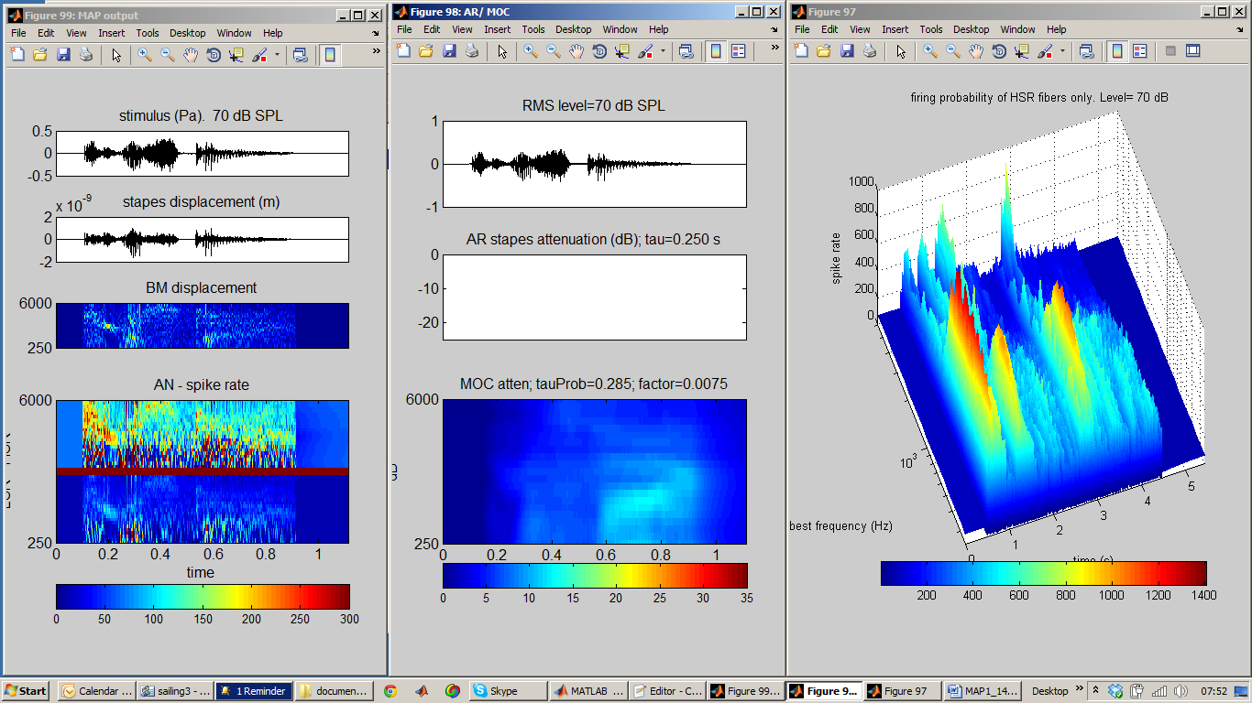
Figure 4. test_MAP1_14; a hands-on program for users to explore the MAP model. Left: model output in probability mode in response to the utterance ‘twister’. Middle: summary of efferent activity. Right: 3D image of HSR AN response.
Basically, this code generates an acoustic waveform scaled in Pascals and presents it to the model. The program user has a range of options that can be selected by modifying the program code. (Don’t forget to make a copy of the original before modification!). The stimulus can be pure tones or the input from a .wav file. The level of the signal (rms) can also be set. The model can be run in probability mode or spikes mode. The number and frequency range of the channels can be changed.
If the following options are selected by default in test_MAP1_14:
MAPparamsName='Normal';
AN_spikesOrProbability='probability';
signalType= 'file';
fileName='twister_44kHz';
leveldBSPL= 70; % dB SPL
numChannels=21;
lowestBF=250; highestBF= 8000;
The output of the model is basically the same as for the demonstration programs except that it generates a third figure showing how the efferent functions have been activated. In this example (using a 70 dB speech signal) the AR reflex is not activated (because the level of the tone is too low) and the MOC reflex (which operates on a channel by channel basis) is moderately activated. The AR can be demonstrated more effectively by generating a pure tone signal and presenting it at 90 dB SPL. The AR attenuates the stapes response once it is activated.
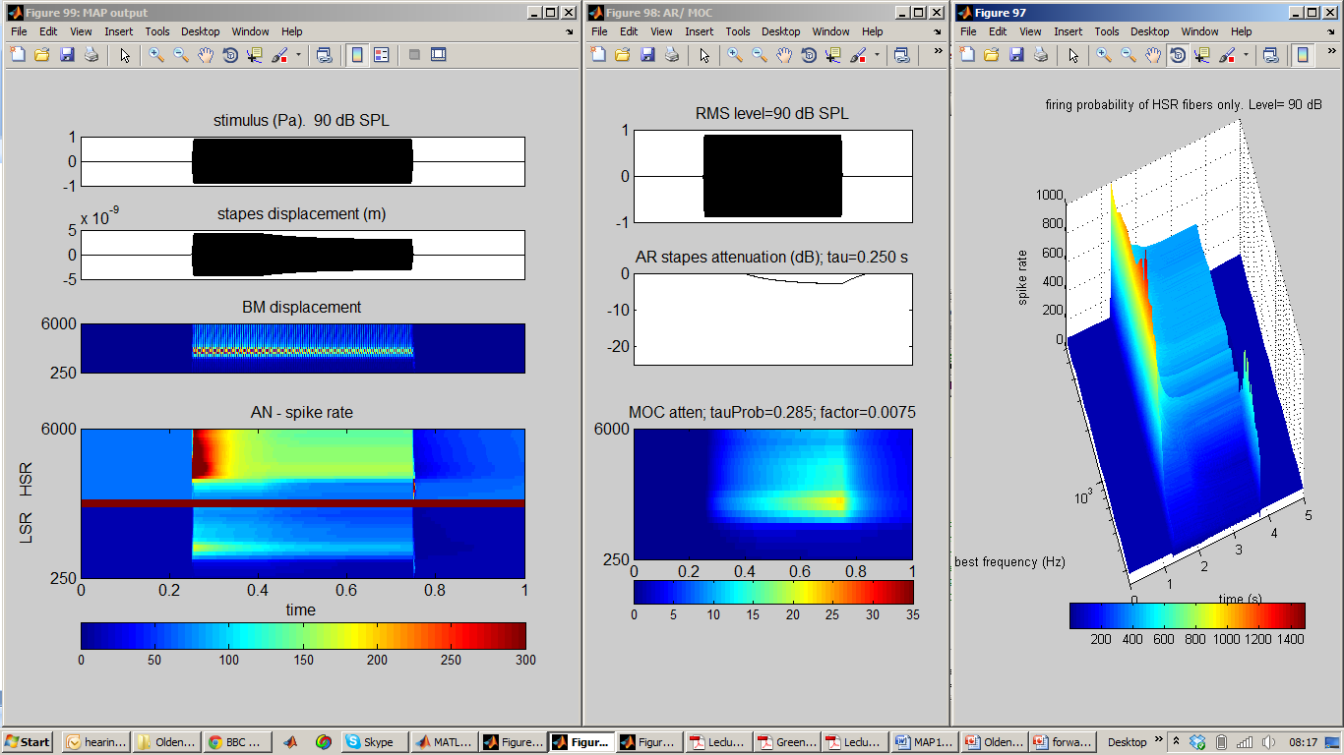
Figure 5. test_MAP1_14; stimulus is a 1–kHz pure tone played at high signal level so as to activate the AR. Left: model output in probability mode. Middle: summary of efferent activity. Right: 3D image of HSR AN response.

MAP 1.14
For many practical purposes, the ‘test_MAP1_14’ program is all that is needed to use the model. This section is intended to give greater insight into the functioning of the model itself for those who wish to understand how it works or who may wish to improve it with further insights into how hearing works.

Model architecture
The two demonstration programs use different model architectures. In both cases the output of one stage is the input to the next stage.

Probability model | Spiking model
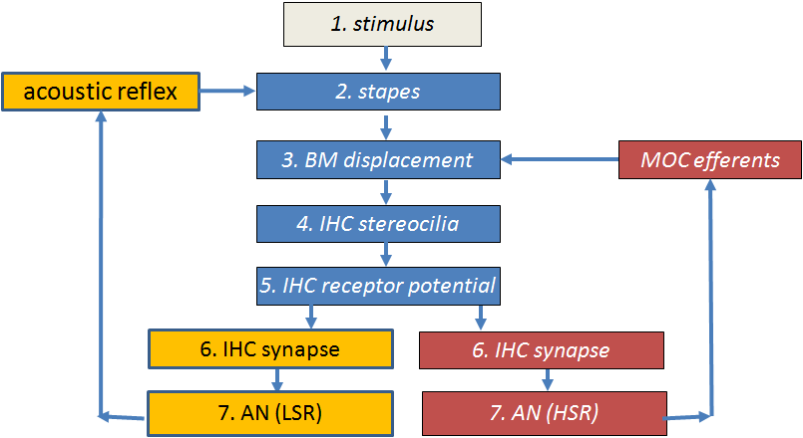 | 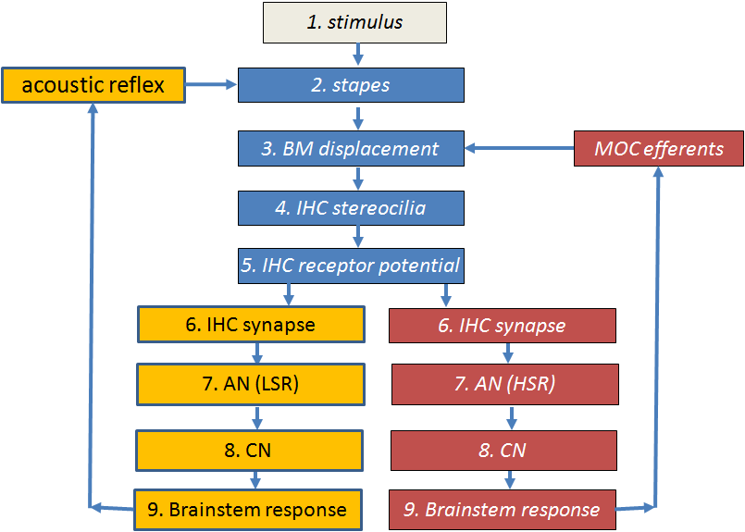
Figure 6. Flow diagrams of the two models implemented in the demonstration programs
Probability model. After the inner hair cell stage, the model bifurcates to give two streams; one for HSR fibers and one for LSR fibers. The probability model ends at the AN fiber stage. The acoustic reflex (AR) and medial olivo cochlear efferent feedback loops are fed back from the AN output. This is not physiologically accurate but it provides a useful approximation for users who want rapid computation.
Spiking model . This takes the spiking output of the AN fibers and feeds them through two neuronal stages. The first simulates CN neurons and the second simulates activity in the medial superior olive (MSO). It is this second stage that is used as the source of the feedback control signals (efferent activity). This is more accurate simulation from a physiological point of view than the probability model but slower to compute.
Efferent effects. The AR efferent activity derives its input from LSR fibers which have high thresholds. This helps to guarantee that the AR is active only at high signal levels. The MOC efferent activity derives its input from the HSR fibers which have low thresholds. The detail of this circuitry is purely speculative in the absence of definitive anatomical evidence.

Model code
MAP1_14.m contains the model code. It is a single program file containing all instructions for executing the model. It is located in the MAP1_14\MAP subfolder.
The function call is
MAP1_14 (inputSignal, sampleRate, BFlist, MAPparamsName, ... AN_spikesOrProbability, paramChanges)
inputSignal is a single row vector in Pascals. (It is a row vector because the model code always regards the x-axis of a matrix as the horizontal time axis.) It is single row because the model only processes mono signals.
sampleRate is the inputSignal sample Rate (Hz)
BFlist is a vector of BFs (in Hz). If this is specified as ‘-1’, the list of BFs is based on the default values specified in the model parameter file (see immediately below).
MAPparamsName e.g. ‘Normal’, is a string used to make up the name of parameter file (e.g. ‘MAPparamsNormal’). The parameter file contains all of the parameters of the model. Parameter files are always located in the folder called parameterStore.
AN_spikesOrProbability
=’spikes’ for full model generating individual spikes in AN as well as simulation of brainstem neuron activity.
=’probability’ for AN model based on spike probabilities. This option computes very much faster that the alternative ‘spikes’ option.
paramChanges is a cell array of strings containing commands to make last-minute changes to the model parameters after loading them from the MAPparams<*> file.

Look at the ‘test_MAP1_14.m’ program (described above) for examples of how MAP1_14 can be called.
At the time of writing, there are 1300 lines of code representing all of the peripheral auditory processing stages. These lines are divided into two groups. The first 550 lines or so are purely concerned with pre-allocating memory and establishing constants to be used in the computations that come later. These lines serve to speed up the execution of the main body of the code. The second half of the code contains the equations that simulate activity at each stage. These equations are described in the companion document
MAP 1_14 Model description.doc.

Segmentation
The model is computed in short segments to allow for efferent feedback (AR and MOC) to be implemented. The segments are typically 10 ms long.

Parameters
At the end of each of the demonstration programs, a complete set of model parameters was printed out in the command window. Their origin is described below.
The model parameters are read from a parameter file to be found in the ‘parameterStore’ folder. For example, ‘MAPparamsNormal’ is a file containing a recommended set of parameters that aims to simulate normal hearing. One of the aims of this project is to create ‘hearing dummies’ to simulate the impaired hearing of patients. Each dummy will have an associated parameter file. The user is free to create new parameter files. If the file names begin with ‘MAPparams’ and are located in the MAP1_14\parameterStore folder, they will be accessible to the MAP1_14 software.
Examine the MAPparamsNormal folder to become acquainted with the parameters required by the model. It is a very substantial list.
Small changes to the ‘Normal’ parameter set can be explored using the paramChanges argument in the call to MAP1_14. This facility changes the parameter without disturbing the original parameter file. The argument is a cell array of strings. Each string is a complete MATLAB statement, exactly as it would occur in the parameter file itself (including the final semi-colon). For example,
paramChanges = {'DRNLParams.a=0;', ‘DRNLParams.g=200’;};
This example makes two changes. It sets DRNLParams.a to zero which disables the nonlinear path in the DRNL model of BM response). It also sets a new value for the gain of the linear path. These parameter changes overrule whatever is to be found in the MAPparams*.m function. To set up a string, copy the whole command from the parameter file, add single quote marks. Separate strings by commas and wrap them in curly brackets. Take care when doing this because MAP1_14 cannot always detect when an inappropriate command is entered. Always check the printout of parameters to make sure that your desired change has been implemented.
These parameters are simply the values that the author has found to be most satisfactory. They are not perfect. If you wish to use them for research purposes, you should ask the author (rmeddis@essex.ac.uk) for the latest versions and any documentary support. This is ‘cutting-edge’ and, no, it is not yet published!

Accessing the model output
The MAP1_14 function draws no pictures nor does it return any output directly to the calling program. The figures generated by the demonstration programs illustrated above are drawn by a utility ‘UTIL_showMAP’ located in the utilities folder.
All model results are stored in global variables. These are left behind in global memory when the program finishes and are readily accessed by the user. ‘UTIL_showMAP’ accesses this global memory to find the data for the displays it creates. All of the available results can be accessed using the following command
global dt ANdt savedBFlist saveAN_spikesOrProbability saveMAPparamsName...
savedInputSignal OMEextEarPressure TMoutput OMEoutput ARattenuation ...
DRNLoutput IHC_cilia_output IHCrestingCiliaCond IHCrestingV...
IHCoutput ANprobRateOutput ANoutput savePavailable ANtauCas ...
CNtauGk CNoutput ICoutput ICmembraneOutput ICfiberTypeRates ...
MOCattenuation

The most commonly required result will be the auditory nerve rate response (spikes/s) stored in the matrix ANprobRateOutput. This is a BFlist x time matrix of estimated spiking rates. The time axis (columns) is sampled at the sampleRate of the signal saved as dt. The list of BFs is stored in savedBFlist. If both LSR and HSR fibers have been simulated the matrix will have twice as many rows and the list of BFs will need to be replicated like this: [savedBFlist savedBFlist].
If the spiking model is used, the AN spikes are stored in the logical array ANoutput using a large epoch value of ANdt.
All values are international units (m, s, Pa, V, A)
To explore these variables, run either the demoTwisterSpikes or demoTwisterProbability scripts to generate sample results. Then execute the global statement above in the command window. All of the outputs should appear in your workspace.

More examples of output stored in global variables
The global variable savedBFlist (row vector) hold the list of BFs used.
saveAN_spikesOrProbability (string) indicates whether ‘spikes’ or ‘probability’ computations were requested.
saveMAPparamsName (string) holds the string (e.g. ‘Normal’) used to generate the name of the parameter file used (e.g. ‘MAPparamsNormal’).
If MAP1_14 is run in probability mode, the AN spike rate matrix (BF x time) can be found in ANprobRateOutput. If two fiber types are used (e.g. HSR and LSR), the top half of the matrix will be the output from the LSR fibers are located at the top of the matrix. When plotting this matrix it is conventional to flip it to put the HSR at the top of the picture and to order the BFs vertically from low to high. The sampling interval for ANprobRateOutput is saved in the variable dt.
If MAP1_14 is run in spikes mode, the AN spiking output will be found in the logical matrix ANoutput. This is a logical matrix (0/1). The sampling interval is ANdt. The sampling rate is different (lower) for these computations because spikes are relatively sparse. Each row of this matrix is an individual fiber. The matrix is a raster plot. Each BF is associated with many fibers (typically 100). All fibers with the same BF and fiber type are in adjacent rows. Fiber types are segregated with HSR fibers occupying consecutive lower-numbered rows,
Output at the early stages of the model is stored in the following variables:
- OMEextEarPressure acoustic pressure
- TMoutput tympanic membrane displacement (m)
- OMEoutput stapes displacement (m)
- DRNLoutput basilar membrane displacement (m) (BF x time)
- IHC_cilia_output IHC cilia displacement (m)
- IHCoutput IHC receptor potential (V)
The amount of efferent activity can be monitored using the variables ARattenuation (single row vector) and MOCattenuation (matrix BFs x time).

Displaying the output
UTIL_showMAP.m is a general purpose function for reporting and plotting the output from the most recent MAP1_14 call. It assumes that all results are already present in global storage. It was, for example, used to generate the figures shown above. It is located in the utilities folder.
UTIL_showMAP (showMapOptions, paramChanges)
UTIL_showMAP is used by the demo files described above. Consult these scripts for examples of how to use it.
It reads all values in from global variables and assumes that MAP1_14 has recently been run, leaving all of its output in global store.
showMAPoptions is a structure containing a number of flags indicating the user’s requirements. It is only necessary to set the required flags; if a flag is missing it is assumed that the option is not required.
paramChanges (string) is described above. It is required to remind the system of changes currently applied to the parameter file. If this is omitted, UTIL_showMAP assumes that no changes were made to the original file. (This will be saved automatically in future).
UTIL_showMAP is able to generate a wide range of displays. These must be selected in the showMapOptions structure. The fields in this structure are all logical (true or false).
showMapOptions.printModelParameters=1; % print model parameters
showMapOptions.showModelOutput=1; % plot all stages output
showMapOptions.printFiringRates=1; % mean activity at all stages
showMapOptions.showACF=1; % SACF (probabilities only)
showMapOptions.showEfferent=1; % plot of efferent activity
showMapOptions.surfProbability=0; % HSR (probability) surf plot
showMapOptions.fileName=[ ]; % parameter filename for plot title

printModelParameters is useful for printing to the command window all the model parameters used.

showModelOutput plots the output of each stage of processing from signal through to the AN and on to the brainstem response if appropriate.
printFiringRates indicates in the command window the overall level of activity in the afferent and efferent stages.
showACF computes and displays the summary autocorrelation function based on the auditory nerve probability response if this was computed.
showEfferent is a plot of the AR and MOC activity levels
surfProbability displays in 3D the activity of the HSR stream of AN fibers
filename specifies the name to appear in the titles of all figures for identification purposes (this will be an argument of the function call in future).

Physiology check-up
MAP is a model based on the known anatomy and physiology of the peripheral auditory system. Its parameters have been chosen to simulate physiological recordings made using small mammals. A number of test programs simulate these physiological experiments as a check that the model is doing what it should be doing. These test programs can either be run individually or as series. Separate programs are available for spikes and probability implementations of MAP.
The test programs, testPhysiology and testPhysiologyProb, can be used to ‘exercise’ MAP to check that it is functioning correctly. To run it you will need to navigate to the testPrograms folder and type on the command line:
testPhysiology(BF, 'Normal', paramChanges) or testPhysiology(BF, 'Normal',)
testPhysiologyProb(BF, 'Normal', paramChanges) or testPhysiologyProb(BF, 'Normal')
This will evaluate MAP1_14 in a single-channel model with a best frequency of BF using the model parameters to be found in MAPparamsNormal but incorporating last-minute parameter changes specified in the final argument. If parameter changes are not required, the final argument can be omitted. testPhysiology runs the model in ‘spikes’ mode while testPhysiologyProb runs is in ‘probability’ mode and is faster.
The programs measure the
- Stapes response at a range of frequencies
- BM I/O function, the MOC elicited by the stimuli and the iso-reponse contour (‘tuning curve) at a number of different response levels
- Various IHC I/O functions of which the most useful is the receptor potential (bottom right).

  - (testPhysiologyProb ) AN firing rate I/O function based on actual spikes (top right)
  - (testPhysiology) AN firing rate I/O function based on actual spikes (top right) also CN and IC I/O functions – one function for each of the fiber types selected.
- Synapse response (available transmitter) as a function of time and level
- (testPhysiology only) Forward masking simulation of an experiment by Harris and Dallos
- (testPhysiology only) AN phase locking assessment based on an experiment by Johnson
The output from the function should look like the following .

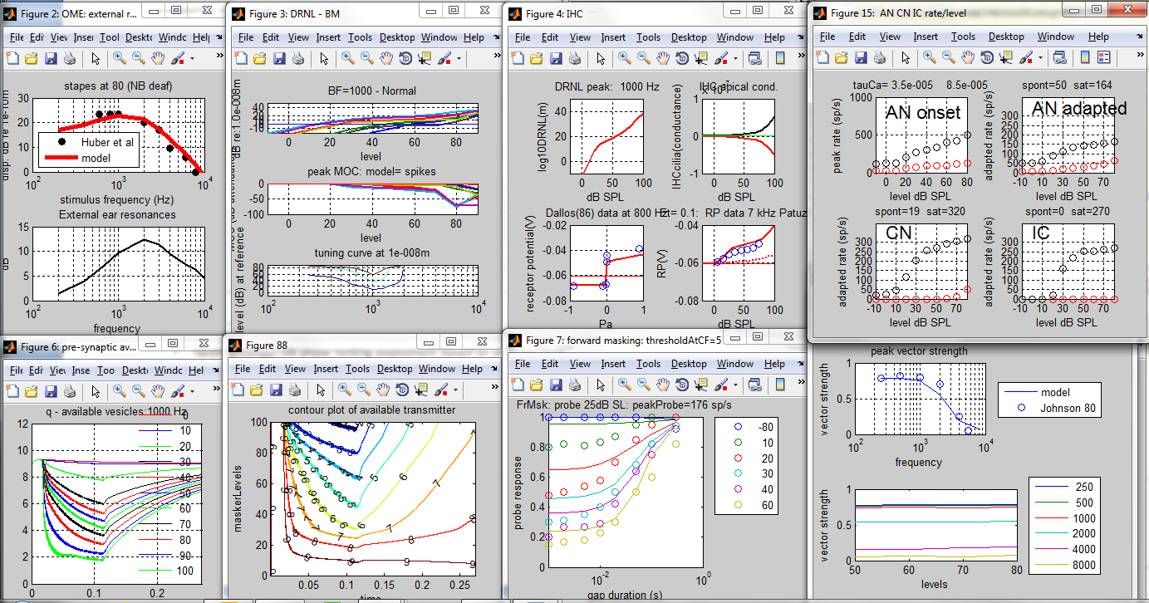
Figure 7. Simulations of physiological experiments using the spikes implementation of the model. testPhysiology(1000, 'Normal', paramChanges)

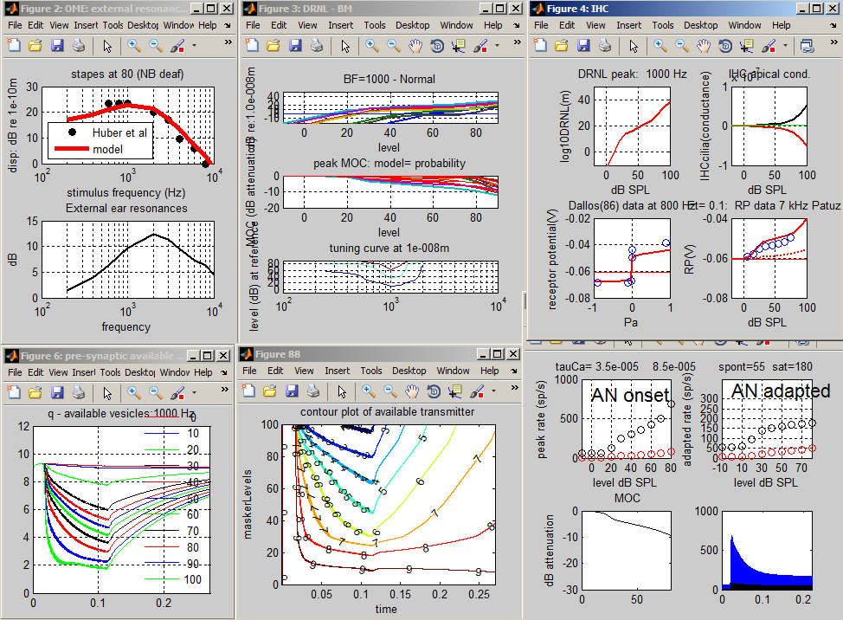
Figure 8. Simulations of physiological experiments using the probability implementation of the model. testPhysiologyProb(1000, 'Normal', paramChanges)

Auditory profiles using multiThreshold
The purpose of auditory model is ultimately to model human hearing to such a degree that the model and the individual cannot be distinguished (a kind of Turing test).
A step in this direction is to administer the same tests to the model that might be applied to the human listener. multiThreshold is a software controller of a range of psychophysical tests that have been designed to be suitable for testing both humans and the MAP model. Three tests are of particular interest; 1) absolute threshold, 2) psychophysical tuning curves and 3) threshold masking curves. These are tests of sensitivity, frequency selectivity and compression respectively.
Here is an example of a hearing profile produced using multiThreshold harnessed to the MAP model and using the MAPparamsNormal parameter set.
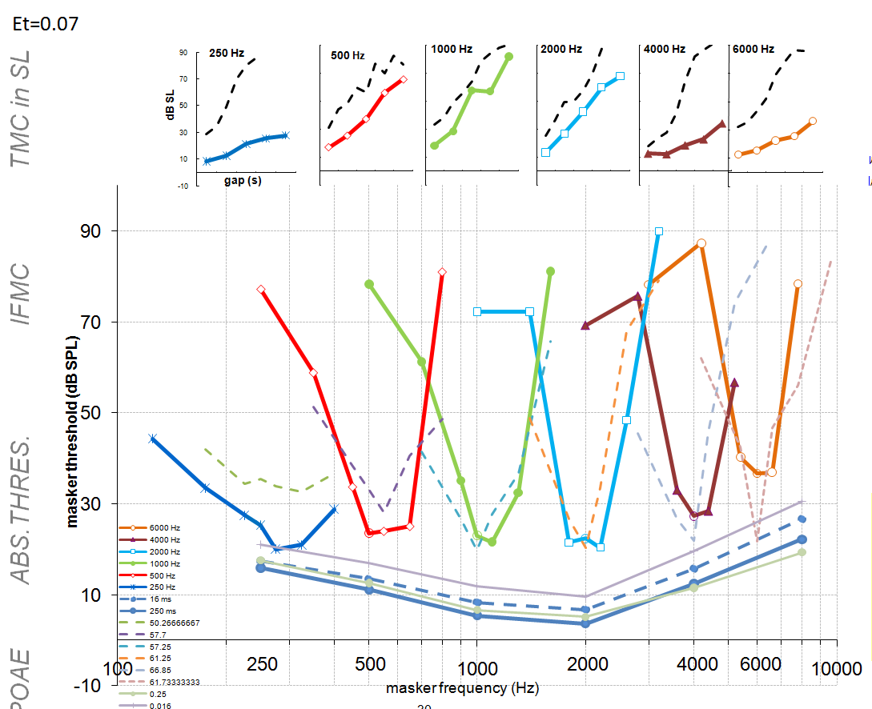
Figure 9. Auditory profile generated using multiThreshold testing software harnessed to MAP, a computer model of the auditory periphery. Top row: temporal masking curves (TMC), an indicator of compression. Middle row: iso-forward masking tuning curves (IFMCs) or psychophysical tuning curves (PTCs), an indicator of frequency-selectivity. Bottom: absolute thresholds for 500-ms tones (thick line), for 16-ms tones, (thin line) and ISO standard (dotted line)
This profile is similar to a profile for a normal human listener original data shown as dotted lines).
Here are two profiles designed to simulated impaired hearing. The faint and dashed lines are data collected from a 20-year old male with good hearing.
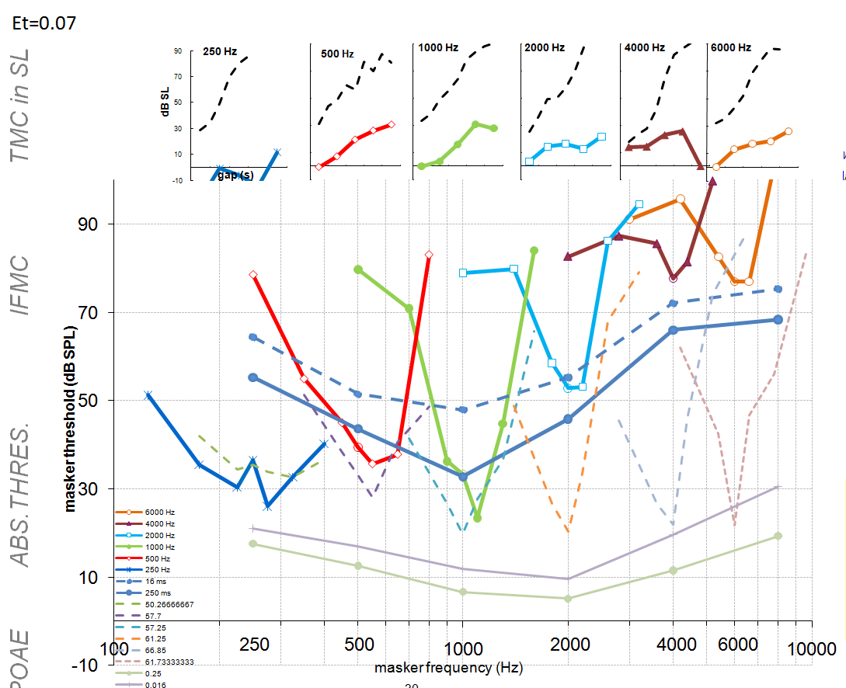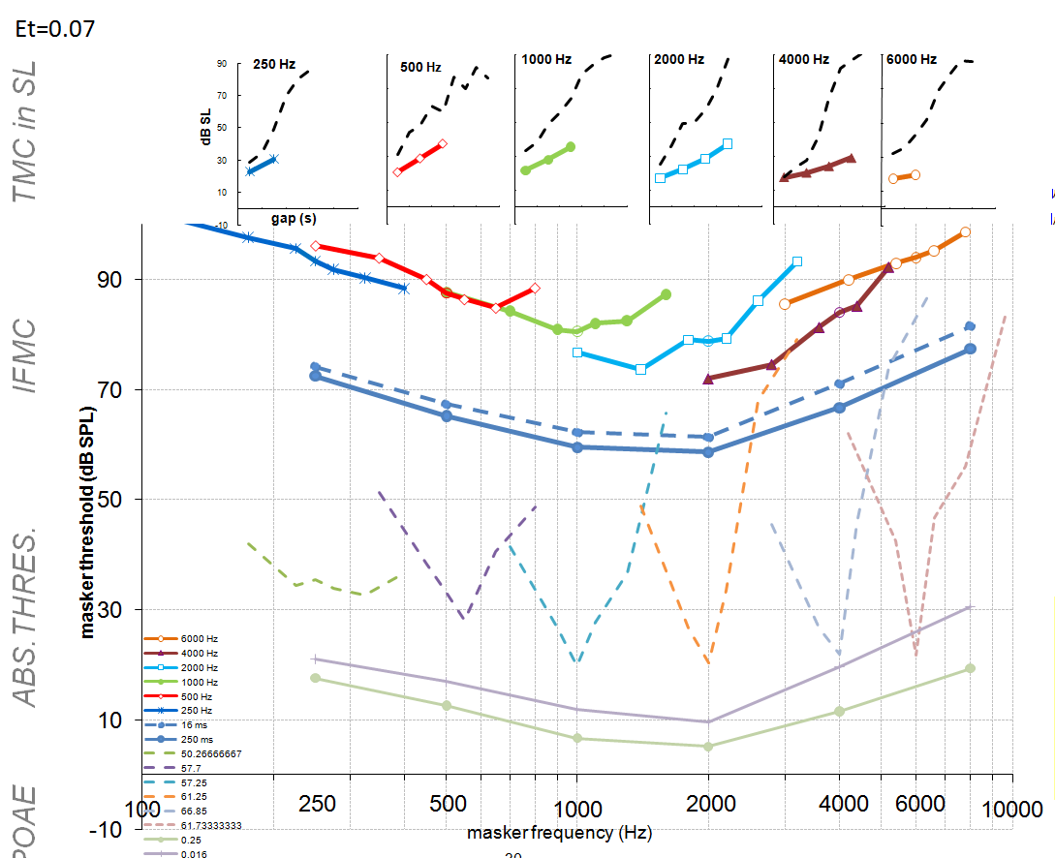
Figure 10. Two auditory profiles generated using multiThreshold testing software harnessed to MAP, a computer model of the auditory periphery. Two different sets of parameters were used. A: the endocochlear potential was reduced to 70 mV but otherwise the parameters were those in the ‘Normal’ file. B: the gain of the nonlinear path in the DRNL filter was reduced to 0, but otherwise the parameters were those in the ‘Normal’ file. The faint lines are normal human data.
In the left panel, the impairment is induced by reducing the endocochlear potential (supplying the inner hair cell, IHC) from 100 mV to 70 mV.
In the right hand panel, an impairment is created by disabling the contribution of all hair cells.
The multiThreshold software can be found in the folder ‘MAP1_14\multiThreshold 1.46’ and is explained in the associated documents:
MAP1_14\multiThreshold 1.46\documentation\MultiThreshold manual.doc
MAP1_14\multiThreshold 1.46\documentation\multiThreshold quickstart instructions.doc

Generating a model profile
A complete profile will be generated using the following procedure
- Navigate to the multithreshold 1.64 folder in the MAP 1_14 folder
- Run expGUI_MT.m to display the GUI.
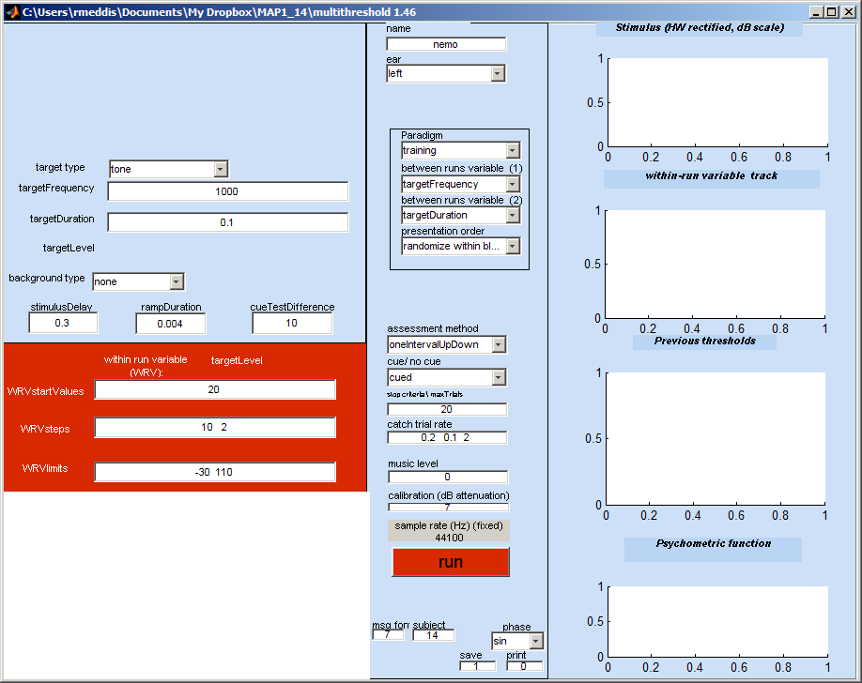
Figure 11. multiThreshold GUI for measuring auditory profiles for both humans and models.
- From the ear menu (middle panel 2nd from top), select ‘MAPmodelSingleChannel’
- From the paradigm menu (below the ‘ear’ menu) , select ‘profile’
- Hit the run button and sit back. A profile should be generated after considerable amount of computation looking like this:
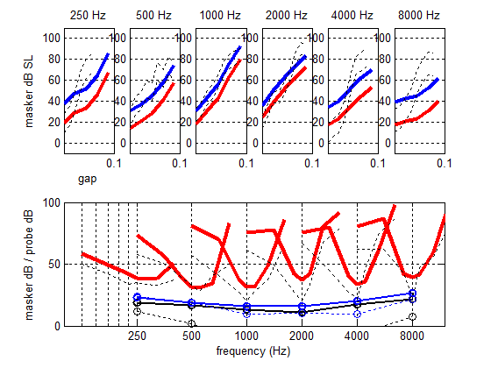
Figure 12. Hearing profile generated by multiThreshold using the computer model as the subject. The ‘Normal’ parameter set was used for this example.
Notes:
- The faint dashed lines on the figure are data collected from a young male listener with normal hearing (CMa). The thicker lines are the model results. The model is tested in the same way as the listener except that no cue is used as it is of no help to the model. The stimulus is presented to the model which has to decide ‘yes’ or ‘no’ according to whether or not the probe was ‘heard’ by the model. The measurement software reacts as if the model’s decision was that of a human listener and generates the next stimulus in the adaptive sequence.
- The thin blue lines in the bottom panel with circles are absolute thresholds for 250 ms and 16-ms tones.
- Frequency selectivity: the V-shaped curves are iso-forward masking contours (IFMCs). A short (16-ms) probe tone is presented at 10 dB SL and is preceded by a 108-ms pure-tone masker. The listener is asked to say whether or not he hears the probe tone. The level of the masker is adjusted until the probe is heard on 50% of presentations. Measurements are made for different masker frequencies (over an octave range covering the probe tone). The IFMC is a record of these masker levels. IFMCs are measured for probes at 250, 500, 1000, 2000, 4000, 8000 Hz and for masker frequencies at 0.5, 0.7, 0.9, 1, 1.1, 1.3 and 1.6 times probe frequency.
- Compression: the top panel records 108-ms pure-tone masker levels required to mask a brief, 16-ms probe tone presented at 10 dB SL on 50 % of presentations. The probe and the masker always have the same frequency but the gap between the masker and the probe is systematically varied between 10 and 90 ms. This is called a temporal masking curve (TMC). The masker levels in dB SL are given as the lower of the two lines. The upper line is the same data presented as dB SPL. The steepness of the line is affected by more than one physiological factor. However, if we assume that the recovery from forward masking occurs at a fixed rate, we can infer that the steepness of the line reflects, at least in part, compression of the response to the masker; most likely either at the basilar membrane or the inner hair cell.
- Diagnosis: in the figure above, the model absolute thresholds are high compared to the human data. The IFMCs are a reasonable fit and the TMCs are a good fit at low frequencies but not at high frequencies. The aim, of course, is to find a set of parameters that offers a good fit to all of the data.

Changing parameters
- The user can seek a better fit by changing the model parameters. The parameters can be found in the parameter file in the folder called ‘parameterStore’. On this occasion the file MAPparamsNormal contains the parameters. This file is specified on the GUI as ‘Normal’ in the edit box called name at the top of the GUI. One way to change the parameters is by altering the parameters in this file and repeating the run.
- If only a small number of parameters need be changed, this can be done on the GUI in the yellow box at the bottom left. This normally contains the empty cell array command paramChanges= {' '}; This can be edited by adding a string inside the quotes, e.g. paramChanges= {' DRNLParams.a=0 '}; Before the run begins, this change is automatically made to the parameters that have been read from the file.
- At the end of each run, a complete list of parameters and their values is printed in the command window. These can be copied and pasted into the GUI (but remember to ad the semi-colon before the final quote.
- If more than one change is required this can be achieved by putting both changes inside their own quotes but separated by a comma (both inside the curly brackets, e.g. paramChanges= {' DRNLParams.a=0 ', ‘DRNLParams.g=500’}; . Line breaks at not currently allowed in this process.
- When paramChanges= {' DRNLParams.a=0 '}; is requested we get a profile that looks like this. This parameter change effectively disables the OHC contribution to the BM response.
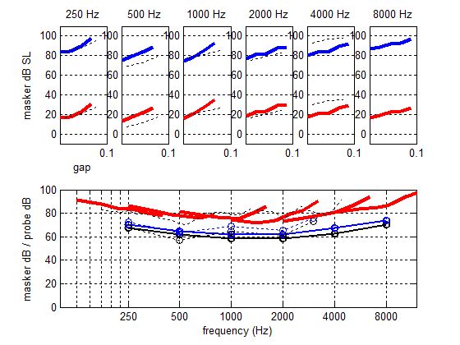
Figure 13. Hearing profile generated by multiThreshold using the computer model as the subject. The ‘Normal’ parameter set has been changed to simulate outer hair cell (OHC) dysfunction.

